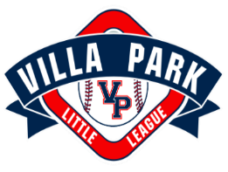
MANAGER/COACH AGREEMENT
I hereby accept the responsibility to be a voluntary Manager/Coach of a Villa Park Little League baseball team for the 2019 playing season. I understand that my appointment was made by the President, ratified by the Board of Directors, and expires at the end of the 2018 playing season. I acknowledge the Little League Baseball Incorporated requirement of being a positive role model at all times for players, coaches, parents and spectators, and I agree to be a positive role model.
I agree to read and strictly comply with all rules and regulations of Little League Baseball Incorporated, and Villa Park Little League. I acknowledge and agree that this shall specifically include, but is not limited to the following:
- Villa Park Little League Code of Conduct
- Facilities Utilization Regulations
- Uniforms and Equipment Regulations
- Safety code for Little League
- Local Rules
- Tournament Play rules /All Star Play rules
- Official Regulations and regular season Playing Rules
I acknowledge and agree that the Board of Directors at its sole discretion, shall have the authority to discipline, suspend or terminate any member of any class (Including me) if conduct of said member is considered detrimental to the Objective of VPLL and/or Little League Baseball Incorporated. Furthermore, I agree to respect and comply with all decisions by the Board of Directors for VPLL.
I understand that team assigned equipment represents a significant cost to Villa Park Little League and I understand that my team’s failure to promptly return team assigned equipment (if applicable) when requested may jeopardize my future association with Villa Park Little League.
I understand it is my responsibility as Manager to ensure umpire coverage for two (2) games this season.
I understand it is my responsibility as Manager to ensure team is current with all monies/fees owed to the league.
I acknowledge and agree to attend a minimum of two (2) mandatory field days this season.

Coach Name___________________________________

Signature _____________________________________Date_________________

President’s Signature ___________________________Date__________________

